Top Bidi Manufacturers in Lucknow
- Sort by
- Ratings
- All Filters
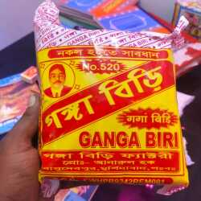
Most searched

Ganga Biri Manufacturing
Trending

Debnath Biri Company Pvt Ltd
4.3
23 Ratings
Kolkata,Rabindra Nagar
Opens at 10:30 am tomorrow
Chat
930 people recently enquired

A. M. Manzoor Bidi Comapny
3.0
1 Ratings
Raebareli,Raebarely Ho
Opens at 9:30 am tomorrow
12 Years in Business
Bidi Manufacturers
Show Number
Get Best Price
Chat
Looking for Bidi Manufacturers?
We'll send you contact details in seconds!

Get Best Price

Popular

Krishna Bidi
4.0
66 Ratings
Sultanpur,Kurwar
Open 24 Hrs
58 Years in Business
Bidi ExportersBidi Manufacturers
Best quality krisna bidi in india
Show Number
Trending

Ramchandar Sindhi Bidi Works
4.5
1 Ratings
Ayodhya,Civil line
Open until 9:00 pm
10 Years in Business
Bidi Manufacturers
Show Number
Trending

Shyam Bidi Works Ltd
3.9
4 Ratings
Allahabad,Allahabad Ho
Opens at 9:30 am tomorrow
Tobacco RetailersBidi Manufacturers
Show Number
Get Best Price
Trending

Shankar Parwati Bidi
4.8
6 Ratings
Bhadohi,Suriyawan
Open until 6:00 pm
80 Years in Business
Bidi ManufacturersBidi Wholesalers
Happiness is not a goal, it is a by-product.
Show Number
Get Best Price
Chat
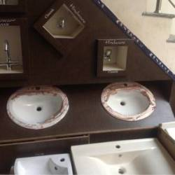

Kumar Tiles & Sanitaries
3.8
12 Ratings
Varanasi,Orderly Bazar
Open until 8:30 pm
12 Years in Business
Tile DealersSanitaryware Dealers
Show Number
Get Best Price
Chat
Were our search results helpful?
YesNo
Trending

Natraj Bidi Mfrg Co
4.5
1 Ratings
Varanasi,Lanka
Open until 9:00 pm
15 Years in Business
Handicraft Item DealersBidi Manufacturers
Show Number
Get Best Price
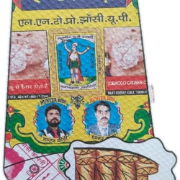
Trending

Hunter Bidi Company
3.9
21 Ratings
Jhansi,Subhashganj
Opens at 10:00 am tomorrow
Bidi ManufacturersBidi Dealers
Good taste and great Quality.
Show Number
Get Best Price

Hantar Bidi Co
3.8
4 Ratings
Jhansi,Manik Chowk
Open until 9:00 pm
14 Years in Business
Bidi Manufacturers
Show Number
Get Best Price
Chat
Trending

JAI Prakash Shivcharan Bidi Company
4.5
1 Ratings
Jhansi,Jhansi Ho
Open until 9:00 pm
14 Years in Business
Bidi ManufacturersBidi Exporters
Show Number
Get Best Price
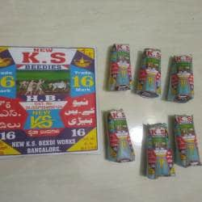

Champion Bidi Works
3.8
2 Ratings
Jhansi,Jhansi Ho
Open until 9:00 pm
14 Years in Business
Bidi Manufacturers
Get Best Price
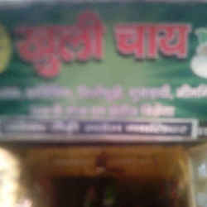
Trending

Parivar Beedi Udyog
5.0
1 Ratings
Gwalior,Lashkar
Open until 9:00 pm
28 Years in Business
Bidi ManufacturersCoffee Vending Machine Dealers
Show Number
Get Best Price
Chat
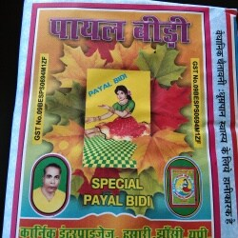
Trending

Karnik Enterprises
5.0
2 Ratings
Jhansi,Hasari
Open until 7:00 pm
18 Years in Business
Bidi Manufacturers
Show Number
Get Best Price
Chat
Trending

Ashok Bidi Company
4.3
3 Ratings
Gwalior,Lashkar
Open until 9:00 pm
14 Years in Business
Bidi ManufacturersTobacco Manufacturers
Show Number
Get Best Price
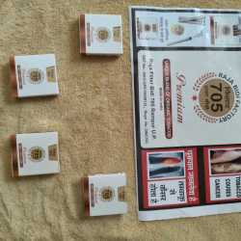
Trending

Raja Bidi 705
4.3
6 Ratings
Rampur,Jail Road
Open until 7:00 pm
Bidi ManufacturersBidi Distributors
Nice bidi like a marlboro advance cigarette , I prefer this bidi to everyone , atleast one should atleast try it .
Show Number
Get Best Price
Chat
Trending

Naresh Bidi Company
4.7
3 Ratings
Gwalior,Gwalior HO
Open until 9:00 pm
14 Years in Business
Bidi ManufacturersTobacco Manufacturers
Show Number
Get Best Price
Chat
Trending

Buland Gold Bidi
4.5
1 Ratings
Aligarh,Adaun
Open until 7:00 pm
11 Years in Business
Bidi ManufacturersBidi Wholesalers
Very nice bidi........please avoid duplicate in future in Himachal, kangra
Show Number
Get Best Price
Chat
Trending

Jhoomar Bidi
5.0
5 Ratings
Jyotiba Phule Nagar,Amroha
Opens at 9:00 am tomorrow
13 Years in Business
Bidi ManufacturersBidi Wholesalers
Show Number
Get Best Price
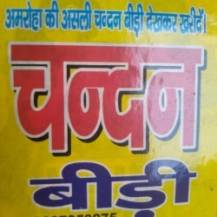
Trending

Chandan Bidi Co
5.0
1 Ratings
Jyotiba Phule Nagar,Amroha
Open until 5:00 pm
11 Years in Business
Bidi Manufacturers
Show Number
Get Best Price
Chat
Trending

Mahboob Bidi Company
5.0
1 Ratings
Jyotiba Phule Nagar,Amroha
Open until 5:00 pm
13 Years in Business
Bidi ManufacturersBidi Wholesalers
Get Best Price
Trending

Turkey Bidi (Hukkey Vali)
5.0
1 Ratings
Jyotiba Phule Nagar,Amroha
Opens at 9:30 am tomorrow
13 Years in Business
Bidi ManufacturersBidi Wholesalers
Show Number
Get Best Price
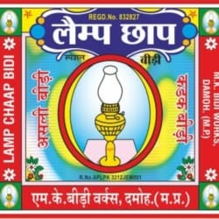
Trending

Lamp Bidi Company
5.0
9 Ratings
Damoh,Futera
Opens at 7:00 am tomorrow
78 Years in Business
Bidi ManufacturersBidi Exporters
Show Number
Get Best Price
Chat
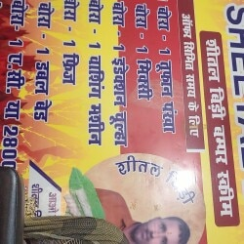

Sheetal bidi
5.0
1 Ratings
Delhi,Surajpur
Bidi Manufacturers
Show Number
Get Best Price
Chat

Pragati Fine Arts
3.0
1 Ratings
Sagar
Opens at 9:00 am tomorrow
13 Years in Business
Bidi Manufacturers
Show Number
Get Best Price
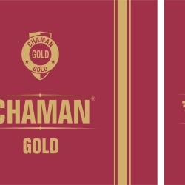
Trending

Chaman Bidi Factory
4.8
8 Ratings
Meerut,Suraj Kund Road
Opens at 9:30 am tomorrow
Bidi ManufacturersBidi Dealers
Show Number
Get Best Price
Chat
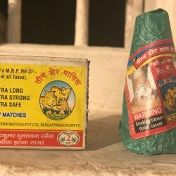
Trending

Manoj Traders
4.8
7 Ratings
Sagar,Bina
Open until 9:00 pm
27 Years in Business
Bidi ManufacturersBidi Wholesalers
Excellent product and services. Overall, best in Sagar.
Show Number
Get Best Price
Chat
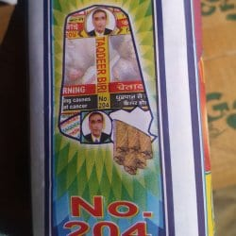
Trending

Jain Bidi Udyog
4.2
7 Ratings
Sagar,Bada Bazar
Opens at 10:00 am tomorrow
12

Om Enterprises
Raebareli
Tobacco Product ManufacturersBidi Manufacturers
Show Number
Get Best Price
Chat
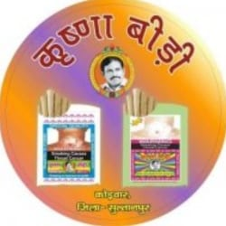

Krishna Bidi
Ayodhya,Kurawan
Open until 9:00 pm
58 Years in Business
Bidi ExportersBidi Manufacturers
Show Number
Get Best Price
Chat

Hasan Traders and Kishan Filter Bidi
Fatehpur-uttar Pradesh,Fatehpur HO
Opens at 9:00 am tomorrow
2 Years in Business
Bidi ManufacturersBidi Wholesalers
Show Number
Get Best Price
Chat

Krishna bidi company
Sultanpur
Bidi Manufacturers
Show Number
Get Best Price
Chat

Varshney General Sales
Allahabad,Allahabad Ho
Open until 9:00 pm
16 Years in Business
Bidi ManufacturersCigarette Manufacturers
Show Number
Get Best Price

M S Up Tobacco Products Pvt Ltd
Allahabad,Bai Ka Bagh
Open until 9:00 pm
Bidi ManufacturersTobacco Product Manufacturers
Show Number
Get Best Price
Chat
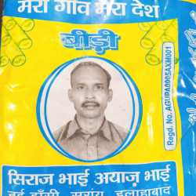

Mera Gaon Mera Desh Bidi Works
Allahabad,Jhunsi
Open until 6:00 pm
Bidi Manufacturers
Show Number
Get Best Price
Chat
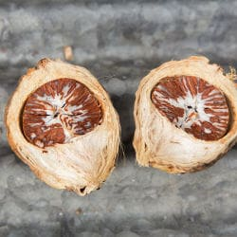

Shyam Cigarette Ltd
Allahabad,Naini
Open until 9:00 pm
16 Years in Business
Bidi ManufacturersCigarette Manufacturers
Show Number
Get Best Price

Neeldeep Tabacco Co Pvt Ltd
Etah,Aliganj
Open 24 Hrs
8 Years in Business
Tobacco WholesalersCigarette Box Manufacturers
Show Number
Get Best Price
Chat

Kumar Enterprises
Bareilly
Open 24 Hrs
Tobacco Product ManufacturersBidi Manufacturers
Show Number
Get Best Price
Chat

Niraj Enterprises
Chhatarpur
Open 24 Hrs
Bidi ManufacturersTobacco Product Manufacturers
Show Number
Get Best Price
Chat
Show Number
Get Best Price
Chat

Sadhu Bidi Company
2.3
2 Ratings
Rampur,Rampur HO
Opens at 9:30 am tomorrow

